**Project Report Mid-Sem**

**Business Management Software**

**Group-09**

**Name-Pravesh Kumar**

**ID-201851091**

**Description-**We make a business management software in this software we add all important feature like store owner portal ,here owner manage entire business like staff management(work, payment), inventory management ,billing system ,Delivery management and accounting,

**Here we describe in detail-:**

You manage is a general purpose business management software. It provides features like accounting, inventory management and billing system. Main objective is to provide an easy and interactive way to manage inventory, accounts and billing systems. The main idea of this project is to reduce the user complexity of traditional accounting systems as users have to learn how to operate them and Owner manage easily our Business.

Our focus is to have a user friendly and compact inventory ,accounting and billing system easily accessible over the internet. Simple and interactive user friendly interface with less complexities. Our idea is actually inspired by the idea of giving the user the best user experience.

It is not for a specific user. Any business owner can Register for it and manage his business himself avoiding extra costs of accountant and others like manage for inventory and manage staff online.

**You mange consists of following systems:**

**Inventory Management:** This system provides users to manage his stocks inventory like adding new items, deleting and updating.

**Billing System:** This system provides user to generate bills and mail them, print them. It also help user to keep track of payments and also track of accounts of borrowers whose payment is either pending or made on monthly or weekly basis.

**Accounting Software:** Keeps track of sales and purchase with accounts of taxes and other accounts.

**Staff Management:** How many day staff active, Payment/bonus of staff.

**Discount management**: On which we can give discount and extra offer.

**Delivery management:** where the product deliver etc.

All the three systems are closely related and help each other so to build a complete business management system we need all these three system to be in close relation and work together for efficient and smith management.

**Strategic Dependency Diagram:**

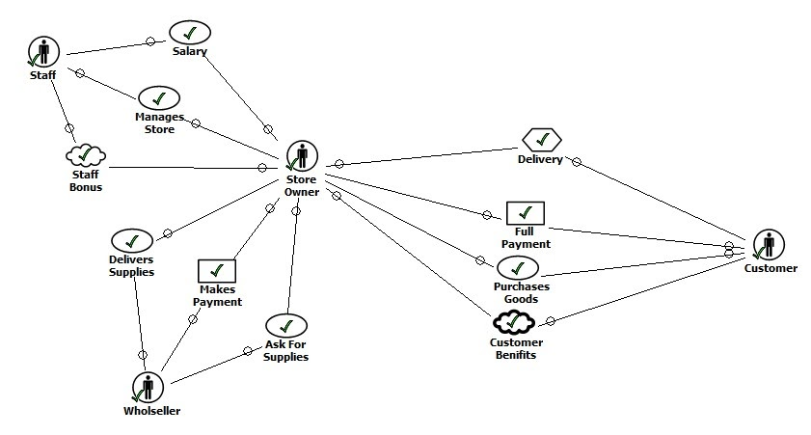

**Strategic Rationale Diagram:**

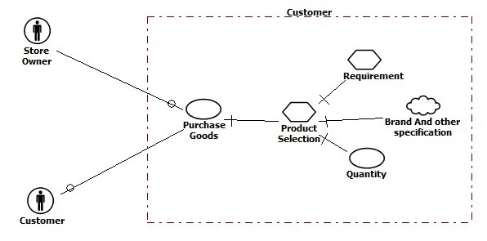

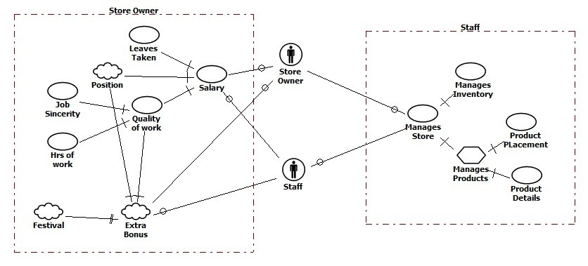

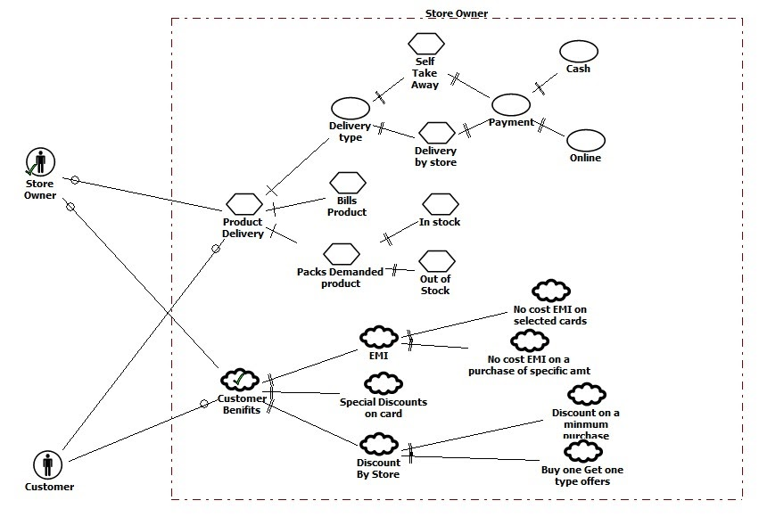

**Open World:**

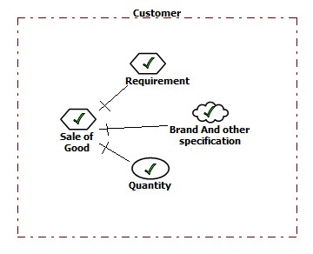

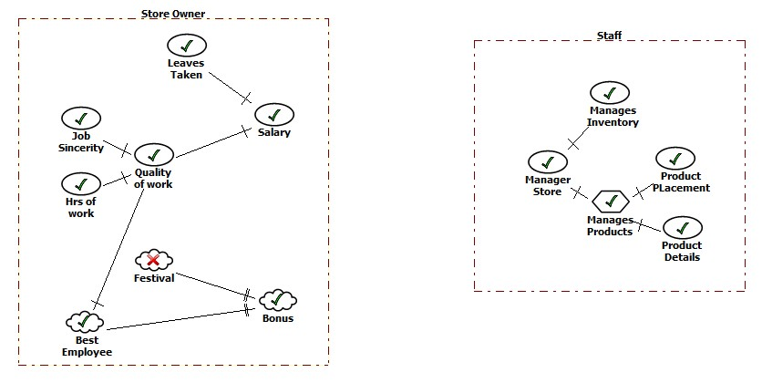

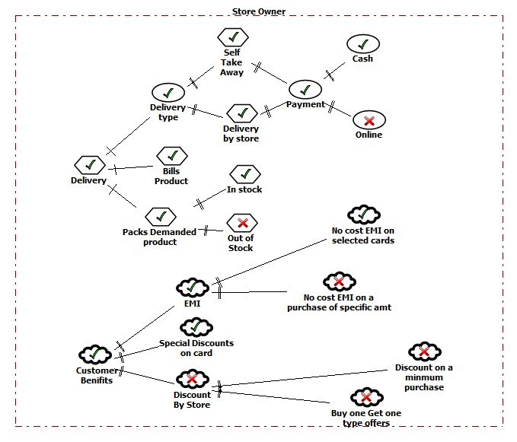

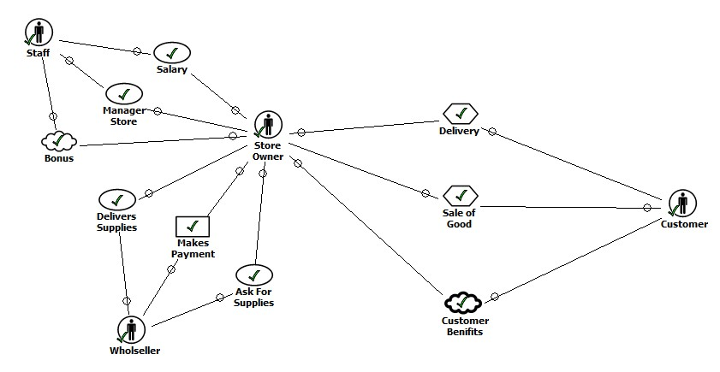

**\*\*In our project close world is not required but we discussed with our group members about close world case.**